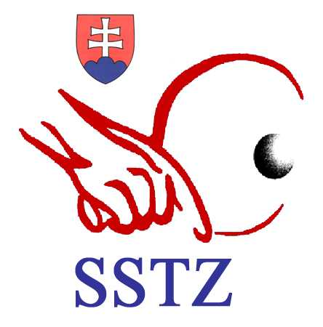

SLOVAK TABLE TENNIS ASSOCIATION

ADDRESS: Černockého 4, 831 53 Bratislava, Slovakia
TELEPHONE: 00421 2 4488 4042
FAX: 00421 2 4488 8615, E-mail: sstz1@ba.telecom.sk
______________________________________________________________________________________________________________________________________________________________________________________________________________________________________________________________________________

TO: Table Tennis Associations
SUBJECT: 14th Slovak Cadet Open 2010
_________________________ __________________________________________________

DATE: 17th July 2010

Dear sports friends,

The Slovak Table Tennis Association invites your cadet boys´ and cadet
girls´ teams to the Slovak Cadet Open held from 5th to 7th November
2010 in Bratislava.
We provide you with the detailed information on this event:
----------------------------------------------------------------------------------------------

ORGANISER : The Slovak Table Tennis Association and ŠK Mostex Rača

ELIGIBILITY: Only players eligible according to the ETTU Regulations
can represent their National Associations at this event
All players born on or after 1st January 1995 are eligible
to participate.

DATE: 5th- 7th November 2010

VENUE: Table Tennis Hall , Bratislava , Černockého ul. 6

COMPETITIONS:
TEAM EVENT - An Association other than the organising Association may
enter 2 boy´s teams and 2 girl´s teams . The organising
Association may enter 1 additional team in each event.
The order of play shall be Corbillon Cup
( AvX,BvY,double,AvY,BvX )
First stage played in groups (according to number of teams)
Second stage K.O. system

SINGLE EVENT - First stage played in groups , second stage K.O. system

DOUBLE EVENT - K.O. system
In all events ( team and individual ) all matches shall be played best of 5 games.

SCHEDULE:

4th November 2010 l6:00 - arrival of the participants
accreditation, accommodation, dinner
20:00 - Jury meeting

5th November 2010 8:30 - teams event
10:00 - draw for individual events
cca 19:30 - teams event final

6th November 2010 8:30 - individual events - cadet boys´
and cadet girls´ singles
- doubles
7th November 2010 9:00 - individual events
cca 14:00 - individual events - finals
8th November 2010 - breakfast and departures

ACCOMMODATION: The participants will be accommodated in the
HOTEL „BARÓNKA “ (4* hotel).
Shuttle bus service will be arranged.

HOSPITALITY COSTS: 80 EUR per person / day (double room)
and 90 EUR per person /day ( single room)
payable at the accreditation. The entry fee
includes full board and lodging from dinner
on 4th November to breakfast on 8th November 2010.

ENTRIES: An Association other than the organising Association may enter 2 boy´s
teams and 2 girl´s teams and may enter up to 6 boys and 6 girls in the
individual events.
The entry forms indicating the nomination of the player have to
be dully filled in and sent to the SLOVAK TABLE TENNIS
ASSOCIATION office either by fax or e-mail latest on 15th October 2010.
The Associations shall list their nominated players in descending order
of playing strength.

Preliminary entries : 30th September 2010

TRANSPORT: The organizer provides a transport from the Vienna Airport
to the venue (Table Tennis Hall - the accreditation office)
and back charging 25 EUR per person.

EQUIPMENT: Tables - Butterfly (green)
Balls - STIGA 40 mm (white)

Ing Anton Hamran PhDr. Zdenko Kríž
General Secretary President of the STTA

