 **5th ETTU CONFERENCE FOR COACHES**

**Dates : 7th – 9th December 2012**

Arrival : Friday 7th December, in the morning if possible between 9h – 13h

Departure : Sunday 9th December, after lunch (Pilsen is 90 km from Prague)

**Conference venue and accommodation at :**

**CONGRESS CENTRE PARKHOTEL PILSEN**

U. Borského Parku 31

320 04 Plzen – Czech R

E-mail : hotel@parkhotel-czech.eu

Websites : <http://www.parkhotel-czech.eu> or [www.pilsenhotel.com](http://www.pilsenhotel.com)

**Cost per person** : Single room 95 Euros per night per person, including hospitality

Double room 80 Euros per person per night, including hospitality

(hospitality full-board including dinner on 7th to lunch on 9th).

Transport from Prague airport to Pilsen and return can be organised at a cost of 20 euros.

Deadline for entries : **20th November 2012**. Please send attached entry form back to the Czech Federation :

Zuzana Kaplanova at [ctta@cstv.cz](mailto:ctta@cstv.cz) and copy to [lila_de_soysa@bluewin.ch](mailto:lila_de_soysa@bluewin.ch)



**« HOW TO BRIDGE THE GAP BETWEEN ASIA & EUROPE ? »**

**PROGRAMME**

**Friday, 7th December 2012 Arrival of participants**

17h00- 17h15 *Welcome and opening remarks*

17h15 – 20h15  **Workshop 1 (Theory and practical)**

**Modern Technique : From mini-cadet to Olympic medallist, the importance of acquiring the right techniques**

**ISTVAN KORPA (GER)**

20h30 *Dinner*

**Saturday, 8th December 2012** 9h00 – 12h00 **Workshop 2 (Theory and practical)**

**TECHNIQUE &** **FOOTWORK**

**LI PING (GER)**

12h30 – 13h30 *Lunch*

14h00 – 16h30 **Presentation of thesis results on « Technical-**

**tactical performance in high level table tennis**

**players of different categories »**

**Presented by Ivan Malagoli Lanzoni (ITA)**

17h00 – 19h00 *Visit to PILSEN BREWERIES*

20h00 *Dinner*

**Sunday 9th December** 09h00 – 13h00 **WORKSHOP 3** – **MENTAL PREPARATION**

**« It’s more fun to win than to lose »**

**SÖREN AHLEN (SWE)**

13h00 *Lunch and departures*

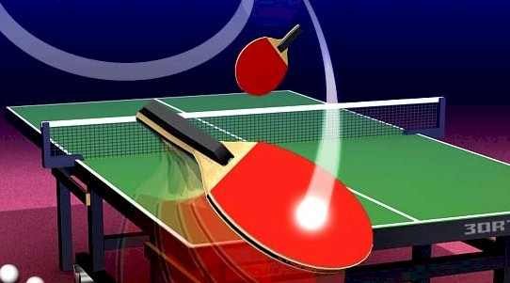

**ENTRY FORM**

 **5th ETTU COACHING CONFERENCE**

**Dates : 7th – 9th December 2012**

Arrival : 7th December

(if arriving by plane at Prague airport and you wish to be picked-up, please try to arrive

**before noon** so we can make a group pick-up from the airport. 90 km between Prague and Pilsen

(Conference begins at 17h on 7th December)

Departure : 9th December, after lunch, **please reserve flights leaving early evening so there is time to drive back to Prague**

**National Association : ……………………………………………………………………..**

|  |  |  |  |  |  |  |
| --- | --- | --- | --- | --- | --- | --- |
| **Full name** | **Gender**  **M/F** | **Arrival date** | **Departure date** | **Rooms single/double** | **Sharing with ?** | **e-mail address** |
|  |  |  |  |  |  |  |
|  |  |  |  |  |  |  |
|  |  |  |  |  |  |  |
|  |  |  |  |  |  |  |
|  |  |  |  |  |  |  |
|  |  |  |  |  |  |  |
|  |  |  |  |  |  |  |
|  |  |  |  |  |  |  |
|  |  |  |  |  |  |  |
|  |  |  |  |  |  |  |
|  |  |  |  |  |  |  |
|  |  |  |  |  |  |  |
|  |  |  |  |  |  |  |
|  |  |  |  |  |  |  |
|  |  |  |  |  |  |  |
|  |  |  |  |  |  |  |
|  |  |  |  |  |  |  |
|  |  |  |  |  |  |  |
|  |  |  |  |  |  |  |

**If you are reserving a double room and know who you would like to share with, please indicate in the column « sharing with ? ». If you reserve a double room without indication, we shall allocate a room-mate for you.**

**The programme ends on Sunday 9th December at 13h.**